Project 1, Part one: Hair Salon

Course name: IT-214

Course number: 007 (Fall 2016)

Name of the student: Bandr Alswyan

**Description**:

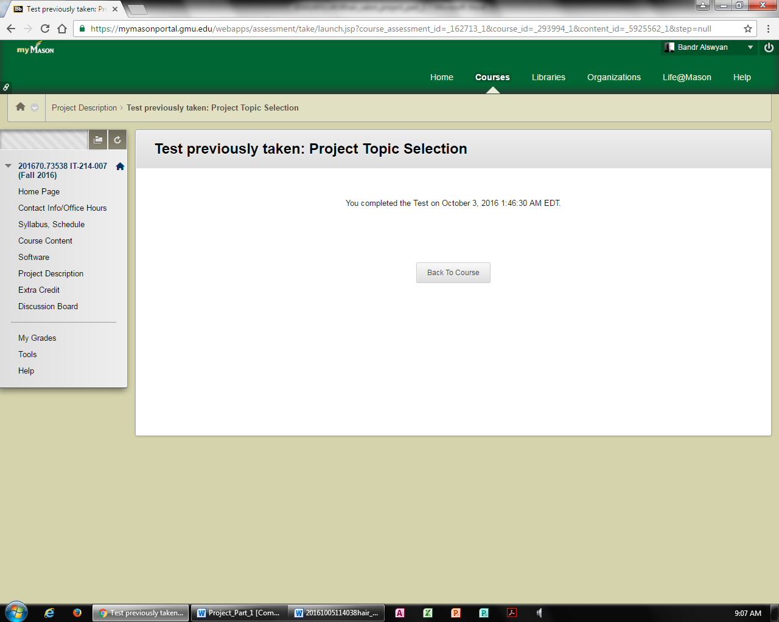

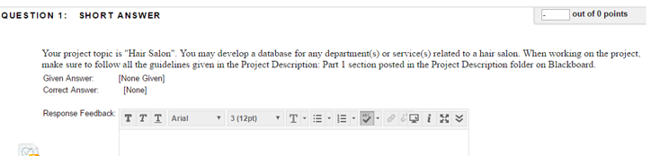

**Your project topic is "Hair Salon". You may develop a database for any department(s) or service(s) related to a hair salon. When working on the project, make sure to follow all the guidelines given in the Project Description: Part 1 section posted in the Project Description folder**

**Description of the company:**

Today, being a salon client has been more of an inconvenience than a necessity since one has to remember to make an appointment with their local salons. This is coupled up with having to remember to do the same during the regular working hours and having to spend more time trying to find the salons number so as to make a booking. This has created a niche for having well-articulated an online one-stop-shop platform that will enable potential clients to make their reservations without any hassle. This will also help in eradicating the need of the salon having to depend on the more tedious and error prone pencil and paper system.

* + **Business requirements for the database:**

The database will also ensure that double booking of clients will be a thing of the past since the end users will be able to clearly and quickly get to know when a customer has been booked and for what service. The database (SERV_APPT) will contain data indicating the type, description and coast of service that the client may need. The database will also hold information about a reservation and which salon employee has been allocated a customer, when and the type of service.

**Business Rules**:

* + Each business rule must follow the format used in class
  + Each business rule must describe a relationship in both directions
  + Each entity and each relationship used in the database must be described in this section
  + Each entity and each relationship described in this section must be presented on the ERD

1. EMPLOYEE must have one or many APPOINTMENT but, an APPOINTMENT must belong to only one EMPLOYEE

1. CLIENT must make one or more APPOINTMENT but, an APPOINTEMNT contains only one client.
2. SERVICE must belong to only one or more SER_APP but, a SER_APP has only one SERVICE.
3. APPOINTMENT must belong to only one or more SER_APP but, a SER_APP has only one APPOINTMENT**.**

**Entities** that includes:

* + Entity’s name
  + Entity’s description
  + List of attributes
  + Data type of each attribute (numeric, text, or date)
  + Sample data for each attribute
  + Constraints (PRIMARY KEY, FOREIGN KEY, UNIQUE, NULL where applicable)

Each entity must be described in the section. You must have a minimum of 4 entities. The total number of entities recommended is 4-5.

|  |  |  |  |  |  |
| --- | --- | --- | --- | --- | --- |
| **Entity** | **Description** | **Attributes** | **Data type** | **Sample Data** | **Constraints** |
| **SERVICE** | Contains details of the SERVICE. | SER_ID | int | 2012 | PK |
| SER_NAME | varchar | haircut |  |
| SER_DURATION | int | 30 |  |
| SER_CHARGE | int | 100 |  |

|  |  |  |  |  |  |
| --- | --- | --- | --- | --- | --- |
| **Entity** | **Description** | **Attributes** | **Data type** | **Sample Data** | **Constraints** |
| **SERV_APPT** | Connecting the details of the SERVICE and APPOINTMENT  “serving as a bridge” | APPT_ID | int | 14567 | PK, FK |
| SER_ID | int | 2012 | PK, FK |
| SERV_APPT_TYPE | varchar | Machine |  |
| SERV_APPT_COST | decimal | $15.12 |  |
| SERV_APPT_DESC | varchar | HC style 2 |  |

|  |  |  |  |  |  |
| --- | --- | --- | --- | --- | --- |
| **Entity** | **Description** | **Attributes** | **Data type** | **Sample Data** | **Constraints** |
| **APPOINTMENT** | Contains details of the APPOINTMENT and serves as a bridge between the CLIENT and the EMPLOYEE | CLIENT_ID | int | 3456 | PK, FK |
| EMP_ID | int | 123 | PK, FK |
| APPT_TIME | time | 9:30 |  |
| APPT_DATE | date | 05/10/2016 |  |
| APPT_ID | int | 14567 | PK |
|
|

|  |  |  |  |  |  |
| --- | --- | --- | --- | --- | --- |
| **Entity** | **Description** | **Attributes** | **Data type** | **Sample Data** | **Constraints** |
| **EMPLOYEE:**  Contains details of the EMPLOYEE. | | EMP_ID | int | 123 | PK |
| EMP_FNAME | varchar | Chris |  |
| EMP_LNAME | varchar | David |  |
| EMP_EMAIL | varchar | CDavid@yahoo.com |  |
| EMP_PHONE | int | 1234567890 |  |

|  |  |  |  |  |  |
| --- | --- | --- | --- | --- | --- |
| **Entity** | **Description** | **Attributes** | **Data type** | **Sample Data** | **Constraints** |
| **CLIENT** | Contains details of the CLIENT. | CLIENT_ID | int | 3456 | PK |
| FNAME | varchar | Lucy |  |
| LNAME | varchar | Martin |  |
| CELLPHONE | int | 23445678 |  |
| EMAIL | varchar | lucy@gmail.com |  |

**Relationships** that includes:

* + A copy of a specific business rule from the Business Rules section for each relationship described here.
  + Relationship’s type: 1:1, 1:M, M:N. Use business rules to justify your decision.
  + Relationship strength: strong or weak. Use business rules to justify your decision.
  + Optionality for both sides of each relationship: mandatory or optional. Use business rules to justify your decision.

Each relationship must be described in the section. Each M:N relationship must be resolved and described.

**Relationship between CLIENT and APPOINTMENT (1:N)**

Each instance of a client must involve one or many instances of appointments. (1,N)

Each instance of appointment must involve an instance of only one client. (1,1)

**Relationship between EMPLOYEE and APPOINTMENT (1:N)**

An employee must have one or many instances of appointments. (1,N)

Instances of appointments may belong to an instances of only one employee. (1,1)

**Relationship between APPOINTMENT and SERV_APPT (1:N)**

An instance of an appointment must belong to one or many SERV_APPT. (1,N)

An instance of a SERV_APPT must have only one appointment. (1,1)

**Relationship between APPOINTMENT and SERV_APPT (1:N)**

An instance of a service must belong to one or many SERV_APPT. (1,N)

An instance of a SERV_APPT must have only one service. (1,1)

1. **Crow's Foot Entity Relationship Diagram**:
   * ERD must be consistent with business rules and descriptions
   * ERD must show all entities and their attributes, relationships, connectivities, constraints, optionality and cardinalities
   * Tables and attributes names must follow naming conventions used in class
   * Each relationship must be properly labeled

# If a composite primary or foreign key is used on ERD, explain your reasoning.

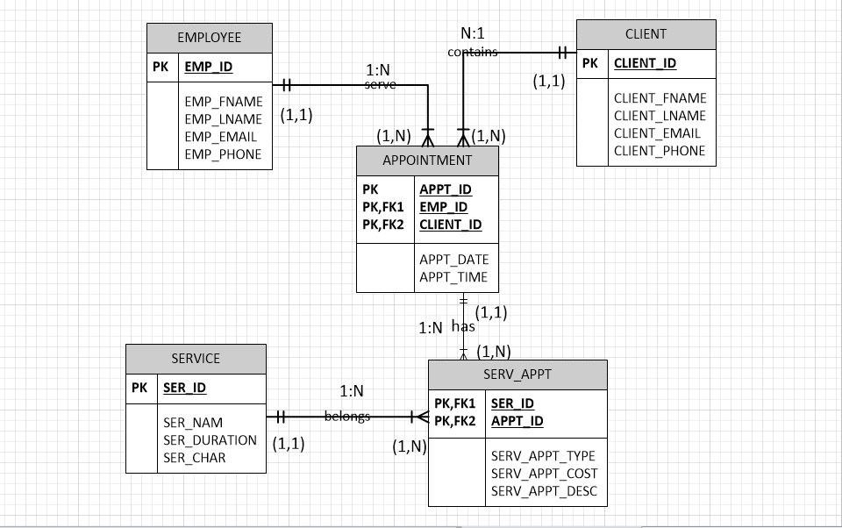

1. APPOINTMENT serve as a bridge between CLIENT and EMPLOYEE, since many EMPLOYEE can have many CLIENT,
2. SERV_APPT serve as a bridge between APPOINTMENT and SERVICE., since many APPOINTMENT can be associated with many SERVICE